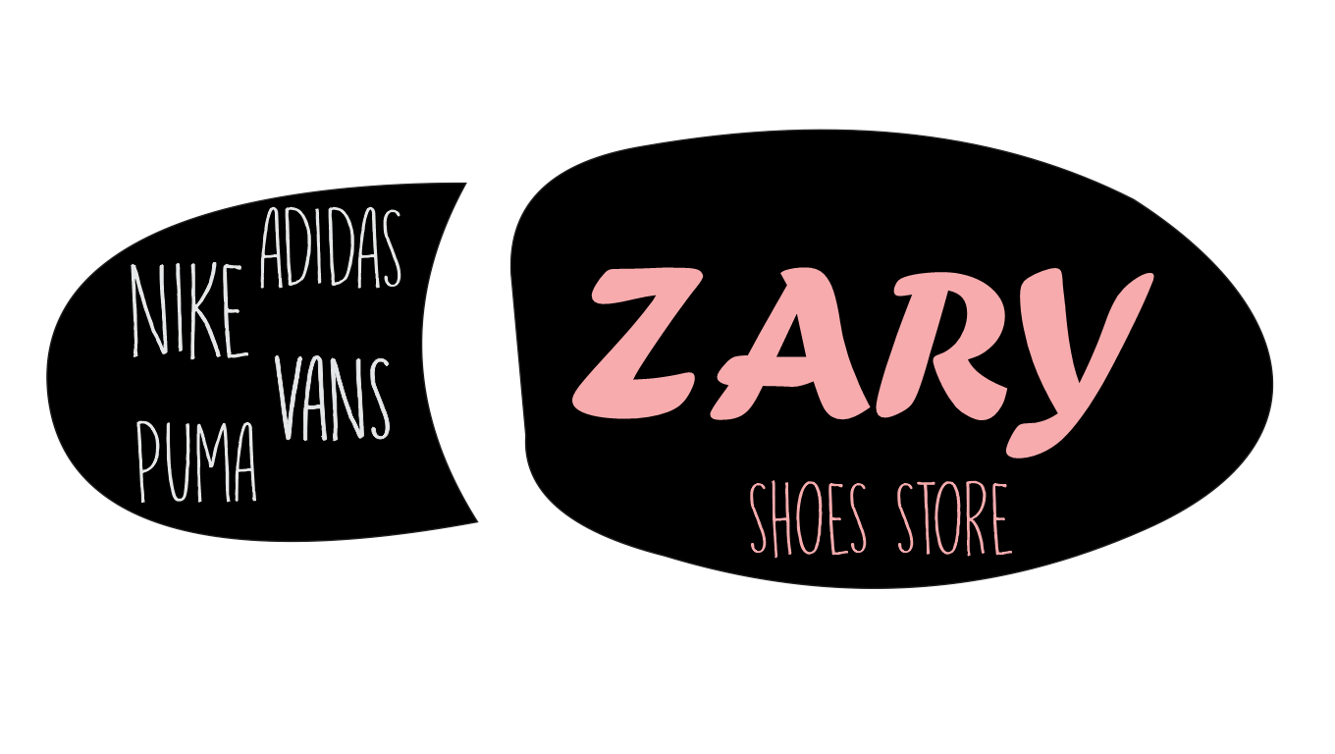

**SALES ASSISTANCE: EVELYN MUÑOZ**

**SALESWOMEN: ISABELA MONSALVE**

**CASHIER: YESICA CARTAGENA**

**WINERY: PAMELA LARGO**

**DIALOGUE IN THE STORE (DIRECT)**

* **ISABELA:** GOOD MORNING!
* **EVELYN:** GOOD MORNING! HOW I CAN HELP YOU?
* **ISABELA:** I´M LOOKING FOR A PAIR OF WHITE SNICKERS
* **EVELYN:** WHAT BRAND ARE YOU LOOKING FOR?
* **ISABELA**: I WOULD LIKE NIKE OR ADIDAS
* **EVELYN:** WHAT STYLE ONE SIZE DO YOU WANT?
* **ISABELA:** SPORT ONE AND SIZE THIRTY SEVEN
* **EVELYN:** WAIT A MOMENTO PLEASE

(***EVELYN GOING TO WINERY***)

* **EVELYN:** I THE REFERENCE SEVENTY TWO AND EIGHTY TWO IN COLOR WHITE IN SIZE THIRTY SEVEN
* **PAMELA:** THE REFERENCE SEVENTY TWO ONLY IS IN SIZE THIRTY SEVEN IN COLOR WHITE
* **EVELYN:** THANK YOU

***(EVELYN CARRY THE TWO REFERENCE TO ISABELA)***

* **EVELYN:** MRS ISABELA. I HAVE PAIR OF SPORT SNICKERS IN COLOR WHITE, IN SIZE´S THIRTY SEVEN. DO YOU WISH TO TAKE THE SPORT SNICKERS?
* **ISABELA:** YES, HOW MUCH DO THEY COST?
* **EVELYN:** IT COSTS 136.939 PESOS

(***ISABELA GOING TO PAY***)

* **YESICA:** GOOD MORNING! THE PRICE TO PAY IS 136.939
* **ISABELA:** THANK YOU! BYE

**REPORED SPEECH DIALOGUE DIRECT**

* THE SALESWOMEN SAID “ GOOD MORNING”
* THE SALES ASSISTANCE ANSWERED “GOOD MORNING! HOW Y COULD HELP YOU?
* THE SALES WOMEN SAID “ I WAS LOOKING FOR A PAIR OF WHITE SKINCKERS
* THE SALES ASSISTANCE ASKED “WHAT BRAND ARE YOU LOOKING FOR?
* THE SALES WOMEN SAID “ I WOULD LOKE NIKE OR ADIDAS”
* THE SALES ASSISTANCE ASKED TO SALESWOMEN “WHAT STYLE AND SIZE DO YOU WANT?”
* THE SALESWOMEN SAID “ SPORTINESS AND SIZE THIRTY SEVEN “
* THE SALES ASSISTANCE SAID “ WAIT A MOMENT PLEASE”

***(THE SALES ASSISTANCE WENT TO WINERY)***

* THE SALES ASSISTANCE SAID TO THE WINERY “THE REFERENCE SEVENTY TWO AND EIGHTY TWO IN COLOR WHITE IN SIZE THIRTY SEVEN “
* THE WINERY SAID “ THE REFERENCE SEVENTY TWO ONLY WAS IN SIZE THIRTY SEVEN IN COLOR WHITE “
* THE SALES ASSISTANCE SAID “ THANK YOU “

***(THE SALES ASSISTANCE IT TOOK THE TWO REFERENCE TO ISABELA)***

* THE SALES ASSISTANCE SAID TO SALESWOMEN “ MRS ISABELA, I HAD FOR A PAIR OF SPORTS SNICKERS IN COLOR WHITE, IT SIZE THIRTY SEVEN”
* THE SALES ASSISTANCE ASKED TO THE SALESWOMEN “DID YOU WISH TO TAKE THE SPORTS SNICKERS?”
* THE SALESWOMEN ANSWERED “YES, HOW MUCH DID THEY COST?”
* THE SALES ASSISTANCE SAID “ IT COSTS 139.939 PESOS “

***(THE SALESWOMEN PAID THE SPORTS SNICKERS)***

* THE WINERY SAID “ GOOD MORNING THE PRINCE TO PAID WAS 139.939”
* THE SALESWOMEN SAID “ THANK YOU”

**REPORTED SPEECH.**

**DIALOGUE: WHATSAPP.**

* THE CUSTOMER SAID SHE WANTED TO ASK ME FOR SOME BLACK NIKE CHOES THAT SHE HAD SEEN ON THE WEB PAGE.
* THE TRADER ASKED ME WHAT DID I WANT TO KNOW.
* THE CUSTOMER ASKED ME IF THEY WERE AVALIABLE, ALSO HOW MUCH DID THEY COST AND WHAT SIZE DID I NEED.
* TH TRADER TOLD ME THAT THEY WERE AVALIABLE AND THEY COST EIHGTY THOUS PESOS. ALSO SHE TOLD ME THAT THERE WERE SIZES FROM 35 TO 42.
* THE CUSTOMER ASKED WHAT WAS THE PLAYING METHOD.
* THE TRADER TOLD ME THAT THE DELIVERY WSA FREE AND I COULD PAY THEY WHEN THEY ARRIVE.
* ALSO, THE TRADER TODL ME IF I ORDERED THEM THAT DAY, THEY WOULD ARRIVE THE NEXT DAY.
* THE CUSTOMER ASKED ME TO SENT HER A PAIR OF BLACK NIKE SHOES SIZE 38.
* THE TRADER ASKED WHAT MY ADDRESS WAS.
* THE CUSTOMER SAID HER ADDRESS WAS 44B STREET NUMERAL 84-32.
* THE TRADER ASKED WHO WAS THE ONE MAKING THE ORDER.
* THE CUSTOMER SAID MISS ELENA WAS MAKING THE TRADE.

**DIALOGUE: WHATSAPP.**

**CLIENT:** HI.

**SELLER:** HELLO.

**CLIENT:** I WANT TO ASK FOR SOME BLACK NIKE SHOES THAT I SAW ON YOUR WEB PAGE.

**SELLER:** YES, CHAT DO YO WANT TO KNOW?

**CLIENT:** ARE THEY AVALIABLE NOW? HOW MUEH DO THEY COST? WHAT SIZES DO YOU HAVE?

**SELLER:** THEY ARE AVALIABLE. THEY COST EIGHTY THOUS AND PESOS ANDE WE HAVE SIZES FROM

35 TO 42.

**CLIENT**: WHAT IS THE PAYMENT METHOD?

**SELLER:** THE DELIVERY IS FREE, YOU CAN PAY IT WHEN THEY ARRIVE.

**CLIENT:** WHEN WILL THEY ARRIVE?

**SELLER:** IF YOU ORDER THEM TODAY THEY WILL ARRIVE TOMORROW.

**CLIENT:** OK, SEND ME ONE PAIR OF BLACK SHOES SIZE 38.

**SELLER:** WHAT IS YOUR ADRESS?

**CLIENT:** 44B STREET NUMERAL 84-32.

**SELLER:** WHO IS ORFERING?

**CLIENT:** MISS ELENA.

**SELLER:** WELL, THANK YOU SO MUCH FOR YOUR ORDER IN ZARY.